Week 4 Assignment | 7.2 Personal Loan Acceptance
7.2(a) k-NN with k=1 classify the given customer
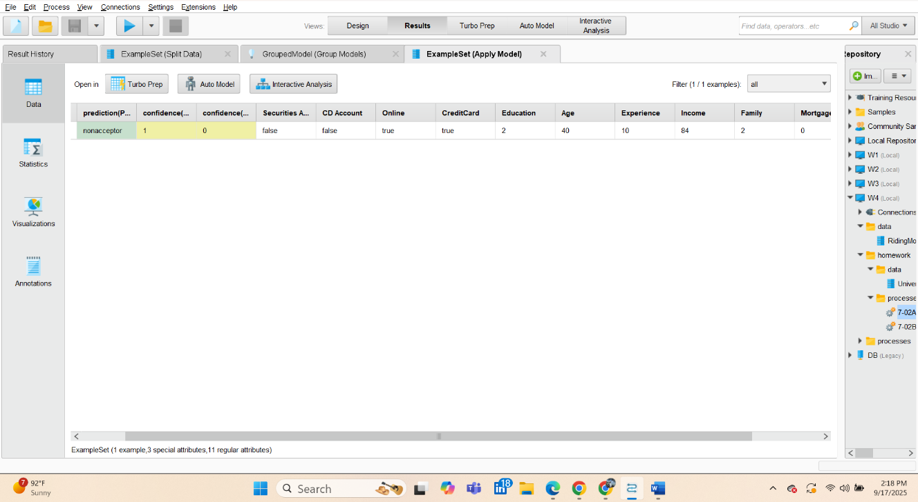
With k = 1, the decision is determined by the single nearest training customer in the normalized feature space. That neighbor belongs to the nonacceptor class, so the vote (and probability-like confidence) is 1.0 for nonacceptor, which exceeds the 0.5 threshold. Therefore, under the specified settings, the customer would not accept the personal loan.

Figure 7.2(a) 1. Model header (k=1)

7.2(b) Model selection with Optimize Parameters (Grid) and nested 10-fold CV
Within the tested grid, k = 13 provides the highest CV accuracy and a reasonable compromise between overfitting (k = 1) and over-smoothing (large k). However, due to class imbalance, acceptor recall is low, so this baseline favors avoiding false positives over catching more acceptors’K-grid results: k = 1, 13, 25 as shown in table.
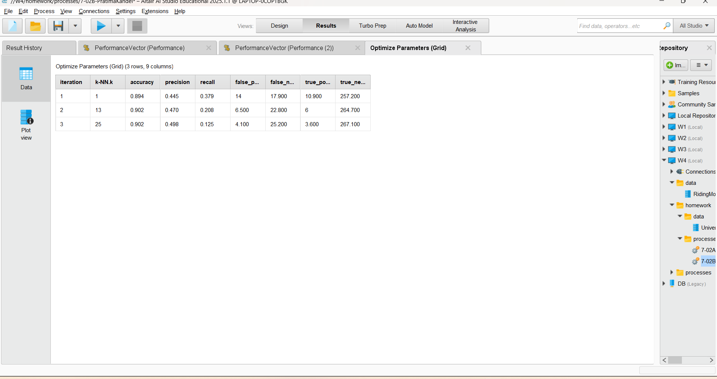
Table 7.2(b)-1. CV results

Best k: 13 (max accuracy).
CV confusion matrix (averaged, best k):
- True nonacceptor: 2671 / 41
- True acceptor: 252 / 36
CV metrics (best k): accuracy 90.23% ± 0.80%; precision (acceptor) 46.75%; recall (acceptor) 12.50%.

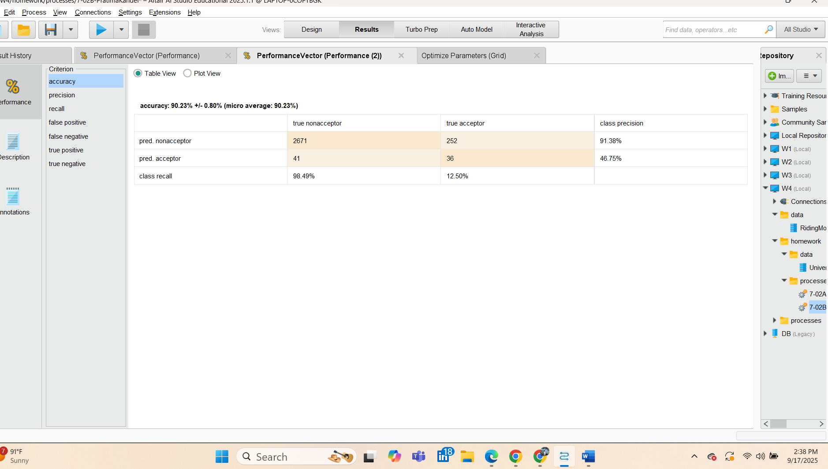

Within the tested grid, k = 13 provides the highest CV accuracy and a reasonable compromise between overfitting (k = 1) and over-smoothing (large k). However, due to class imbalance, acceptor recall is low, so this baseline favors avoiding false positives over catching more acceptors

7.2(c) Holdout evaluation with best k (k = 13)
Using the model selected in 7.2(b) (k = 13), we scored the 40% holdout set. The resulting confusion matrix and performance metrics are:
- Confusion matrix (holdout):
True nonacceptor: 1791 predicted nonacceptor, 17 predicted acceptors
True acceptor: 162 predicted nonacceptor, 30 predicted acceptors
- Accuracy: 91.05%
- Precision (acceptor): 63.83%
- Recall (acceptor): 15.62%
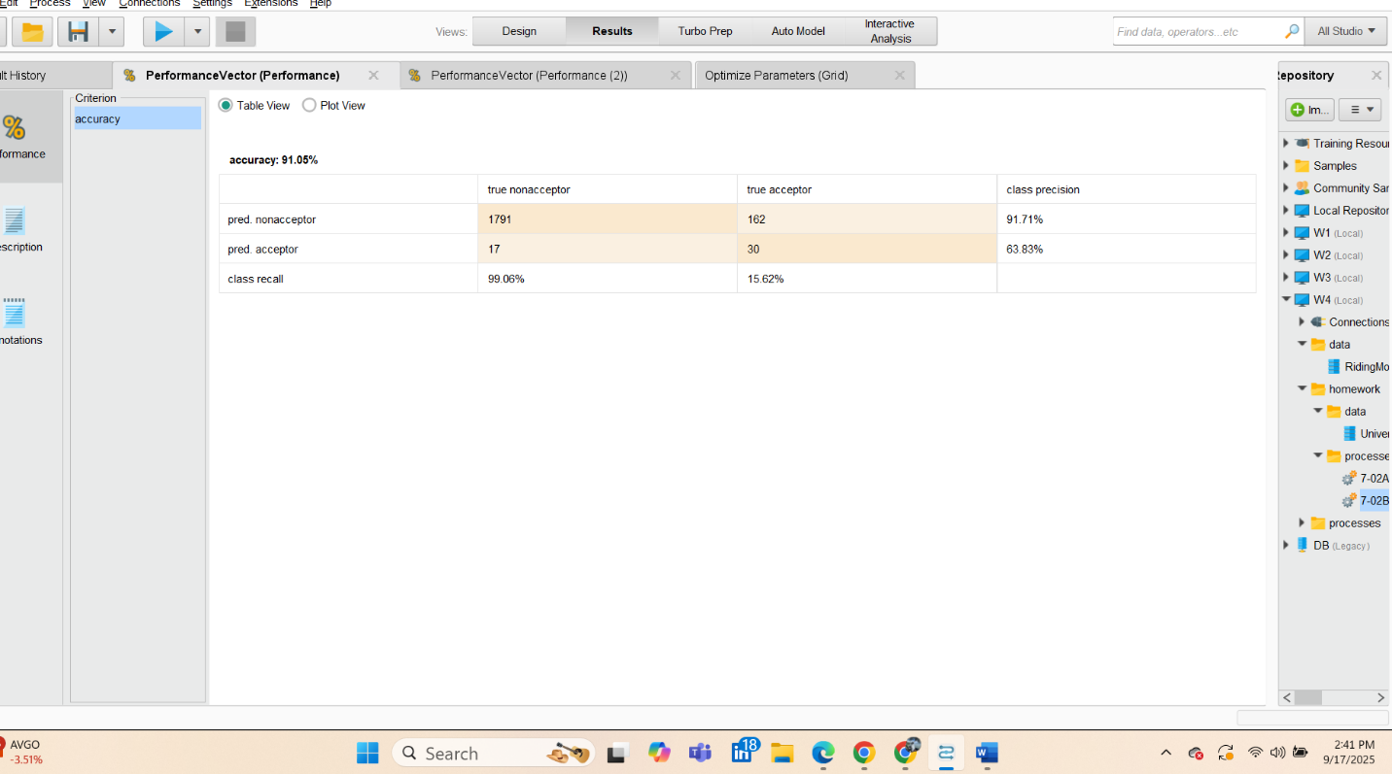
- Specificity (nonacceptor): 99.06%

Interpretation. On unseen data the model stays around 91% accuracy and is excellent at running out non-acceptors but still captures only a small share of true acceptors. Improving recall will require threshold or training-time strategies that explicitly address the class imbalance.

